**RGI60-01.0037** : Images not loading

**RGI60-01.0038** : Some of the traces are along the moraine. It is detecting some ice/rock boundaries.

2019: Only a few images have a complete ELA trace.

2020: Sporadic traces (ex: 2020-07-03)

**Wolverine:**

2017: Only one image is loading, unsure if my laptop is just being weird though. Testing again later.

**RGI60-01.00046:** No distinct ELA traces for 2016, 2017, 2018, 2019, 2020, 2021

Mostly tracing this area:

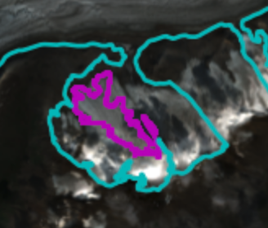

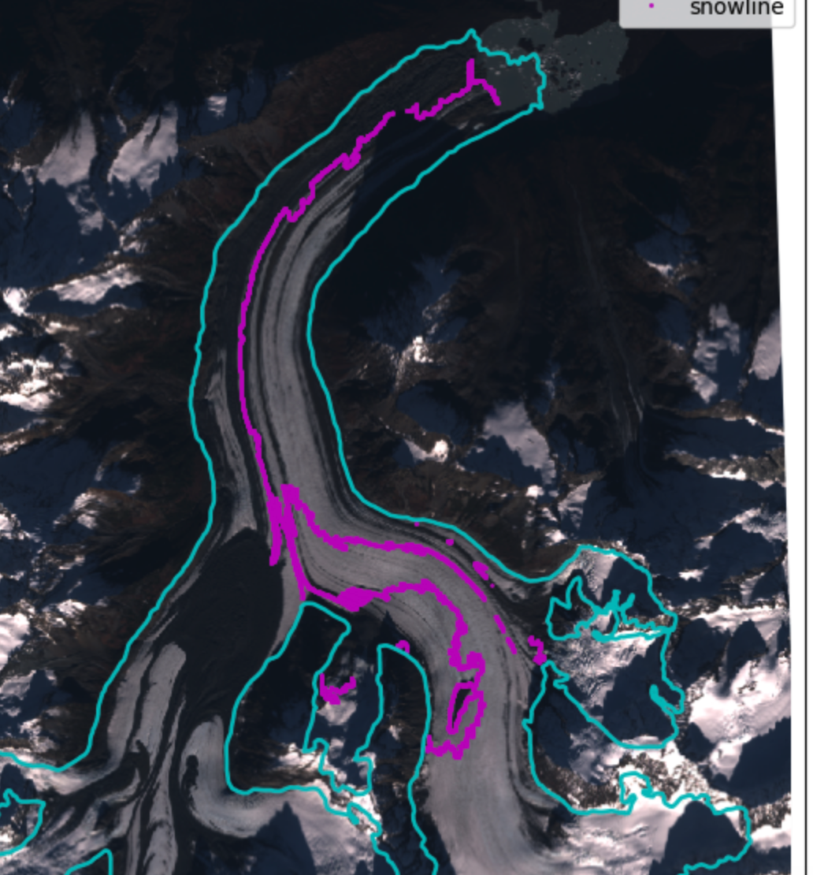

**RGI60-01.01733**

2016:

**RGI60-01.11788:** For 2022, I selected two dates. I chose the second one because although it was slightly lower, it marked the ice/snow boundary really well.

2022-08-04 & 2022-08-12

**RGI60-01.23597:** For 2016, there were no distinct ELA traces. I did not select an image for this year.

For 2018, I chose two dates. The first was chosen based on the accuracy of the snowline trace, while the second image did not have a very accurate trace but the image clearly shows the ELA with the highest elevation.

2018-07-27 & 2018-07-16

**RGI60-01.26743:** I chose two sites in 2021.

2021-08-29 & 2021-09-11

**RGI60-02.12435:** For 2016, there was only one distinct snowline trace.

For 2017, there were only partial traces.

29-Aug-2023: reran snowlines

**Sit Kusa:** Whacky snowlines!

29-Aug-2023: reran snowlines

**RGI60-01.11788:** 2016 had a really low snowline.

I chose two for 2018. One of them looked kind of fuzzy, wanted to ask for a second opinion.

**RGI60-02.04363:** 2016 had a really low snowline.

2018, 2019, 2020, 2021, 2022 had no snowlines! I did not make a selection for these years yet.

**RGI60-01.20180:** 2016 had some wonky snowlines.

2017 only had a few images, chose the best one.

**RGI60-01.20180:** Want opinion on where the snowline is, not sure about some of them (2018)

**RGI60-01.16262:** No snowlines for 2017

**RGI60-02.17738:** No snowlines for 2021.

**RGI60-02.14256:** No snowlines for 2021.

**RGI60-02.14256:** No snowlines for 2021.

**RGI60-02.14009:** No snowlines for 2021.

**RGI60-01.20186:** No snowliines for 2021, 2018

***RGI60-01.23597:*** The glaciers were snow covered! DONE

2020 - will need to edit points in QGIS.

2021 - will need to edit points in QGIS.

**RGI60-02.02364;**

2016 - Will need to edit points in QGIS. Made choice based more on image and not pink snowline.

**RGI60-01.20309;**

2022 had mostly snow covered glaciers.

2021 - picked one with a minimal snowline, and the other choice has no snow. :(

2018will need to manually edit the ELA line. This glacier is mostly rock. :(

**Blue**

Take a look at the earlier-season ELAs and compare the figures/ folder as a check